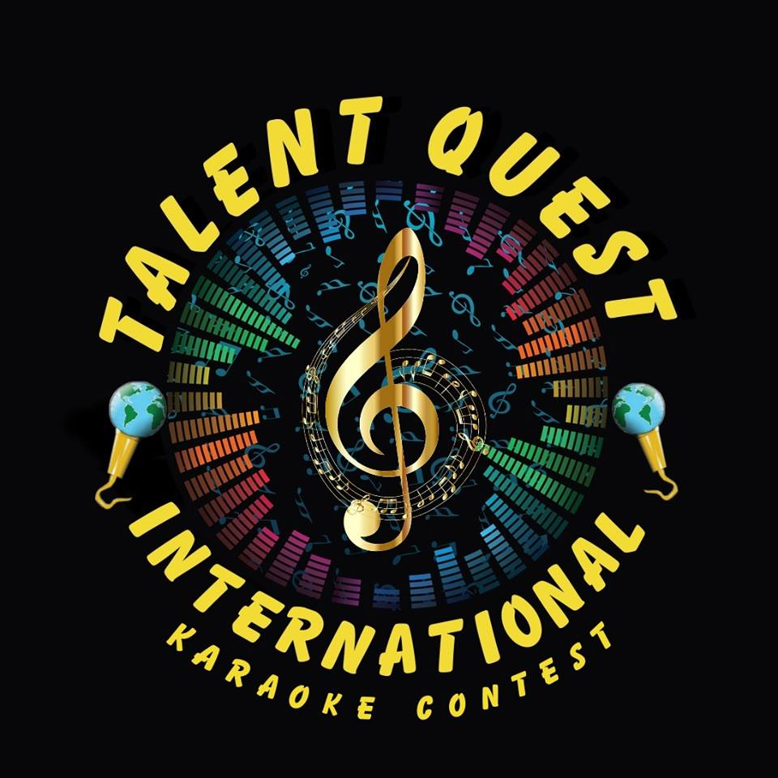

Welcome to Talent Quest International Karaoke Contest. We are the longest running International Karaoke singing/performance competition in the World. We are pleased to announce our 25th season is in full motion.
We are not American Idol or the Voice. We are looking for REAL talented amateurs. We are looking for your best singers to represent your area or State or Country at the International contest. Get your bar involved in the Best contest in the Country.
Don’t miss out on the chance to Show case your best singer’s talent on our International Stage.

There are 6 International Categories to compete in:
Open - Male and Female, Country-Male and Female, Masters- Male and Female (50 & over)
(Open category is anything that is not Country, Rap, Hip/Hop and Urban)
Check out our Promo Video at www.youtube.com/watch?v=tIVzz_iobrU
If you are interested in Hosting a Talent Quest Contest, or would like more info please contact
your local State Representative or contact us at
talentquestinternational@yahoo.com for more info

